

Department of Computer Science & Engineering

PROGRAM OF STUDY: Computer Science

SUBJECT: System Analysis and Design

SUBJECT CODE: ACSC 155

Academic Year: 2010-2011

Semester: Fall

TABLE OF CONTENTS

1. Information Systems 3
1.1 What is a System 3
1.2 What is an Information System? 3
2. Systems Analysis - Introduction 4
2.1 What is Systems Analysis & Design? 4
3. SYSTEMS ANALYSIS 4
3.1 SYSTEM DEVELOPMENT LIFE CYCLE (SDLC) 4
3.1.1 Computer Assistant Software Engineering (CASE) 8
3.1.2 Users 9
3.2 Design by prototyping 11
3.3 SYSTEMS INVESTIGATION 13
4. Process Modeling 17
5. Systems Design 21
6. Input/Output Design and user interfaces 25
7. TESTING and DEBUGGING 33
7.1 TESTING 33
7.2 Debugging 34
7.3 Installation - Integration 36

1. Information Systems

1.1 What is a System
A system is a set of components that interact to accomplish some purpose. e.g. College system, Economic system, Language system, a Business and its parts - Marketing, Sales, Research, Shipping, Accounting, Government.

1.2 What is an Information System?

Information System (I.S.): Interrelated components working together to collect, process, store, and disseminate information to support decision making, coordination control analysis and visualization in an organization.

Input
Processing
Classify
Arrange
Calculate
Output
FEEDBACK

ORGANIZATION
INFORMATION SYSTEM

Information: Data that have been shaped into a form that is meaningful and useful to human beings.

Data: Streams of raw facts representing events occurring in organizations.

Input: The capture or collection of raw data from within the organization or from its external environment.

Processing: The conversion, manipulation, and analysis of raw input into a form that is more meaningful to humans.

Output: The distribution of processed information to the people or activities where it will be used.

Feedback: Output that is returned to the appropriate members of the organization to help them evaluate or correct the input.

Computer-Based I.S. (CBIS): I.S. that rely on computer hardware and software for processing and disseminating information.

2. Systems Analysis - Introduction

2.1 What is Systems Analysis & Design?
The process of examining a (business) situation with the intent of improving it through better procedures and methods.

System Analysis - Process of gathering and interpreting facts, diagnosing problems, and using the facts to improve the system.

Systems Design - Process of planning a new system to replace or complement the old. Analysis specifies what the system should do and design states how to achieve the objective.
Note : This examination should always be initiated by the people involved in the situation (or who will be involved in a new situation). It is the job of the analyst to suggest solutions, but not make business decisions. (A computer based solution is not necessarily the only one!).

What Systems Analysis is NOT
Studying a business to decide which existing procedures should be handled by the computer and which should be done by non-computer methods.

- Determining what changes should be made.
- Initiate new procedures and practices.

3. SYSTEMS ANALYSIS

OPORTUNITY TO IMPROVE A SYSTEM

3.1 SYSTEM DEVELOPMENT LIFE CYCLE (SDLC)
A System development life cycle (SDLC) is a process by which systems analysts, software engineers, programmers, and end users build information systems and computer applications. It constists of 5 stages.

S1. Problem Identification (First stage - What is the problem)
Systems Planning: ongoing study of a problem environment to identify problem-solving possibilities.
Identify and prioritize those technologies and applications that will return the most value to the business.

e.g.
Stock control system
- Location of each item ile number, shelf etc.
- Which sell most?
- Which is the most profitable?

S2. System Analysis
Priorization of the requirements for solving the problem. The emphasis is on the business, not the computer.
In other words, is the study of current business and information system, and the definition of user requirements and priorities for new information system. Synonyms include business problem analysis, requirement analysis, and logical design.
Basically, WHAT TO DO, NOT HOW TO DO IT.

What should system do?
- keep records of sales
- keep records of stock levels - produce sales reports

Feasibility Study
Advantages Vs Disadvantage

T Technical feasibility (technically practical, staff, expertise)
E Economic feasibility
- Is it cost effective?
L Law feasibility
- Is it legal?
O Operational feasibility
- Does it fulfil user requirements?
- To what degree?
- Will the work environment change?
- How does users feel about such a solution?
S Schedule feasibility
- Design and implementation in acceptable period of time?

S3. System Design
The evaluation of alternative problem solutions and the detailed specifications of the final solution computer-based. Emphasis shifts from the business to the computer solution.
Sent to programmers.
It is also called physical design.
Basically, HOW TO DO IT.

Logical
- What data to hold?
- Which process to transform data?

Physical
- Which software and hardware to use?
- Decided on a package which could be modified

S4. System Implementation
The construction or assembly of the new system and the delivery of that system into “production” (meaning “day-to-day operation”).

Buy and install hardware
- Install software
- Set up data files
- "Test Run" system
- "Go live"

S5. System Support & Maintenance
The ongoing maintenance and enhancement of a system after it has been placed into operation. This includes program maintenance and system improvements.
- Enhancements to software
- to produce reports on certain items only “group" items and sort into various orders for reports.

3.1 (Continued) Systems Development Life Cycle - Main Steps
- Produce Identification Terms of Reference
- Preliminary Analysis Feasibility Reports
- Systems Analysis Functional Specification
- Systems Design Detailed Systems Specification
- Implementation Fully documented System
- Maintenance Test Runs

System Life Cycle

The feasibility study

GO AHEAD?
Abort project

No
Detailed
System analysis
Maintenance
yes

Detailed system Design
Specification

implementation physical system testing and change over

Figure 3.1: System Development Life Cycle

Project: a sequence of activities that have one goal or purpose and that must be completed by a specific time, within a predefined budjet, and according to some specification.

Project Manager: The person responsible for supervising a system project from its initiation to its completion.

3.1.1 Computer Assistant Software Engineering (CASE)
The use of automated tools that support the drawing and analysis of system models and associated specifications. Some case tools also provide prototyping and code generation capabilities. You can think of the CASE technology as a software that is used to design and implement other software(s) (similar to the CAD technology for engineers).

Project Management tools and Techniques

PERT CHART (Project Evaluation and Review Technique)
A graphical network model used to depict the interdependencies between project tasks.

Example: A PERT Chart diagram for the Analysis phase of a system project

LABEL | ACTIVITY | PREDECESSOR | DURATION
A | Conduct Interviews | None | 3
B | Administer Questionaires | A | 4
C | Collect Company Reports | None | 4
D | Analyze Data Flow | B,C | 8
E | Introduce Prototype | B,C | 5
F | Observe Reactions to Prototype | E | 3
G | Perform Cost/Benefit Analysis | D | 2
H | Prepare Proposal | G | 2
I | Present Proposal | H | 2

Table 3.1: Activities of the Analysis phase

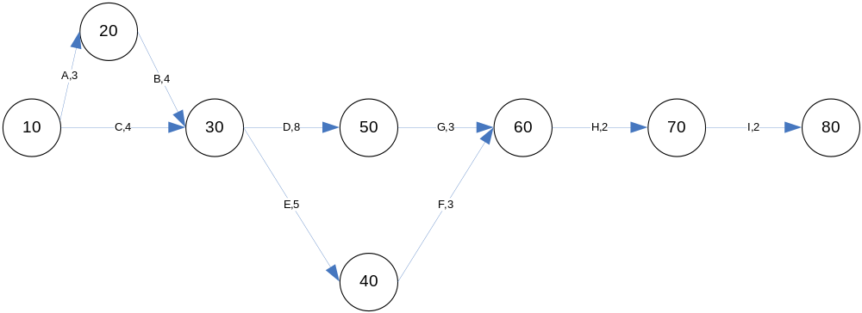

Figure 3.2: PERT Chart for the analysis phase

Gantt Chart
A simple time-charting tool used for project scheduling and progress evaluation. A bar chart to depict project tasks against a calendar.

Example:
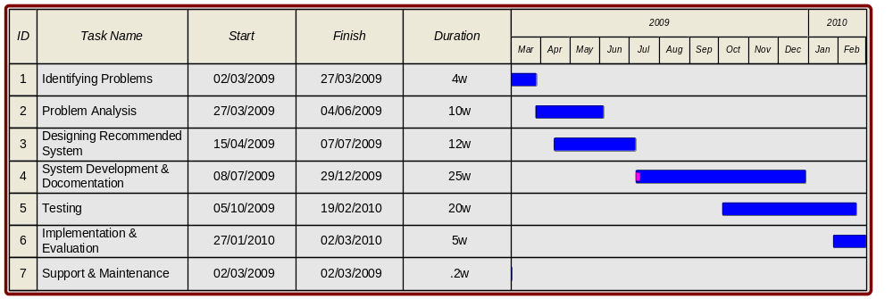
Figure 3.3: Gantt Chart for the System Development.

3.1.2 Users
Direct
- interact with the system direct
- initiate Administrative - Money
- Actually interact with the system. They feed in data or receive output, possibly using a terminal. A new system will considerably change the daily work of these users.

Indirect Users
Benefit from the results of reports produced by the Computer System. These users may be managers of business functions using the system.

Administrative Users
Users that have management responsibilities for Application systems. These users may use systems directly or indirectly, but they retain authority to approve or disapprove investment in the development of Application systems.

People involved in Analysis

Business Analysts (B.A.) – Identification Feasibility Analysis
Conducting system studies to learn the relevant facts about a business activity. The emphasis is on determining information and processing requirements. Their responsibilities do not include systems design.

Systems Designers (S.D.) – Design
Begin after the initial investigation by Business Analysts and use that information to design the system. The emphasis is on converting the requirements into processes (programs) and data (files or database). They do not write programs but do investigate available software and hardware.

Systems Analysts - Everything
They combine the responsibilities of B.A. and S.D.

Analyst Programmers - Everything (or what they know)
Combine responsibilities of S.A. and Programmers, i.e. they also develop the software to implement the design.

What does a Systems Analyst do?
- Conduct a study of the feasibility of the proposed system.
- Liaise with users of the system and determine their requirements.
- Find out the facts relevant to the design of the proposed system.
- Determine the human and computer procedures that will make up the system, designing forms, files, reports.
- Write program specifications.
- Test the programs and the system.
- Participate in the implementation of the system.
- Document the system.
- Do anything else that will produce an efficient and effective system.

What skills does a system analyst need?
- The ability to communicate verbally and in writing.
- To extract relevant facts - a Detective.
- To obtain information in a reasonable way - a Diplomat.
- To interpret a jumble of facts and convert them into a logical form.
- To understand and have a broad knowledge of modern computer hardware & software.
- To keep up-to-date on System Methodologies.
- To be creative.

S.A. Characteristics: trusted, develop ideas in an objective way, range of social skills, patient, perceptive, fair, unbiased, persistent, good listener, empathy.

Questions

- How would you define an "effective system"?

- Would a system produced by analyst programmers be more or less "effective" than one produced by separate people?

- Users have a right to influence systems design. Do you agree with this?

- Do users have a responsibility to participate in systems design?

People involved in Systems Investigation

Systems Analysts - all types.

Computer Systems Managers - in the areas of Data entry, Hardware selection, Database Administration, Operations and Project Management.

Users - all types.

Systems Consultants - people with specialist expertise, e.g. a particular business activity or database selection.

Internal Auditors - to ensure adequate internal controls and that the systems output can be audited.

Managers of the organisation - facilitating the required resource allocations and formally accepting the developed systems.

Objections to the life cycle model
A major criticism of the life cycle model is the time-scale associated with its linear progression of activities. The gap between specification iand delivery is often so long that requirements change dramatically in time. This leads to the delivery of systems that "were required two years ago".

Also, the specification itself is often not understood by the users responsible for agreeing it. It is often given in computer terms described of such length that there is little chance of the user really being able to assess if it actually represents his requirements. Consequently, many delivered systems have to undergo changes that reflect misunderstanding and altered circumstances. This is often euphemistically called maintenance.

An alternative approach
Known as prototype has claimed advantages in most aspects of the life cycle. Prototypes are a first attempt at a design which is then extended and enhanced through a series of iterations.

3.2 Design by prototyping
Prototype: “an original or model on which something is patterned” and/or “a first full scale”.

Prototyping stresses the early delivery of an incomplete but working system and the use of prototypes may be valuable at various stages of the life cycle.

Users have to specify their requirements in advance (unclear to a user how a system may help him, either because the role of the computer is not understood, or because the information needed are unclear). Difficult for most users to clearly envisage what they want and how they can use it until they are able to experiment with a tangible system.

So, a simple prototype designed to accommodate broad needs, together with possibilities suggested by the designer using experience gained in other projects may be used to define requirements more accurately.

Prototype
It is a live working system not just a paper based. Users can test its operation and explore its facilities and so do not have to rely upon written descriptions. It is an iterative process.

The prototype approach

Analyst

The prototype approach User

USER ANALYST
Identifies basic information requirements

Analyst develops system that fullfil basic requirements

Experiments with
basic system in actual
application

Analyst refines prototype
system to reflect identified requirements

Questions
- Outline a comparison between the two approaches of designing a system that is the system life cycle and the prototype.

- Identify the negative and positive aspects of each one of them? Which one would you use and why?

Advantages – disadvantages
Technology & Strategy of prototyping

3.3 SYSTEMS INVESTIGATION

1. Interview
2. Questionnaire
3. Record Inspection
4. Observation

Fact finding
  - What (information)
  - When (to be produced)
  - How (is to be presented)
  - Why (is it wanted)

1. Model existing system
Model the object system before and after interviews
objects - people and processes
messages - forms, documents, reports

- Before investigation - Informal
- After investigation - Formal - DFDs - Data flow diagram(s)
LDSs - Logical data structures(s)

2. Search for external similar systems
By talking to colleagues, researching in library, using own past experience
- gives prompts for questions
- suggests alternatives
- learn from other's mistakes and avoid them

Local search in existing system
purpose of data, information, report
new information for improvement
(information from interviewing, but it is often useful to look at existing user manuals before interviews)

- Interviewing
Start at the top always asking permission to interview subordinates - ask them as well.
Usefull information can be extracted from interviewing, but it is often useful to look at existing user manuals before interviews
Basic Processes; Data; Limitations; Controls; Enhancements
You will need a check-list before you conduct the interview

Main questions in mind
- What is the basic business process?
- What is the purpose of this business activity?
- What steps are performed?
- Where are they performed? Who performs them?
- How long does this take?
- How often is it done?
- Who uses the resulting information?
- What data is used and/or produced during the process? Ask to see "records".
- What are the limits imposed by time and the volume of work? What "triggers" the activity? When does this happen? When must it be completed? How often does it happen (volumes)?
- What performance controls are used?
- Are there specific performance standards? Who compares performance against standards? How are mistakes caught and the errors handled? Are the errors excessive?

How to Conduct a Successful Interview
- Make an appointment in advance, advise on nature of interview, should be no longer than 1 hour.
- Prepare in advance, learn about individual to be interviewed, become familiar with topic, prepare appropriate set of questions.
- During the interview:
Introduction: Begin with general questions; Follow up on topics & issues; Limit note taking; Summarize at end.
- After interview document results and send copy to interviewee.
- Consider follow-up interview(s).

- Questionnaires
Large number of "users"
Distributed over large geographical area
General public users

5. Record investigation
Necessary for data analysis and definition

6. Observation
Watch "users" work
Work with "users"
Partial observation, user `talks through' process

Advantages & Disadvantages of ivestigation methods
- Interviewing
Advantage: Straight from the "horse's mouth".
Disadvantage: Without initial model or existing system, very difficult to know where to start (time consuming).

- Questionnaires
Advantage: Time saving when a lot of far flung interview would otherwise be required.
Disadvantage: Unrepresentative sample due to low response.

- Record Inspection
Advantage: Impossible to investigate current system without seeing documentation.
(Imagine describing in detail an order form in an interview).
Disadvantage: You could be viewing out-of-date, used differently now documents.

- Observation
Advantage: See informal system.
See exactly which documents are used and how.
Disadvantage: Observes may feel under pressure to go by the book.
Time.

Problems in Investigation
- Commitment to old system
- Resistance to change
- Embarrassment
- Fear of Job Loss
- Lack of interest
- Analyst's lack of skill. Conflicting interests
- Territorial Instincts
- Expressing position too early

Project Initiation
- A problem with the existing system.
- New technology - greater benefits or lower costs.
- Formalise manual or informal system.
- New information required.
- Resources become available for ‘frozen’ investigation.

Past History
- Little Analysis
- Poorly Defined Tasks
- Well defined User Role

End Products
Lengthy Narrative Specifications
1. Difficult to: Read, Understand, Change
2. Confused: Requirements, Design, Implementation

Resulting Systems
1. Took too long to build
2. Cost too much
3. Failed to meet requirements
4. Failed to meet constraints
5. Were inflexible
6. Were poorly documented

System Analysis
- HOW WOULD YOU DEFINE AN "EFFECTIVE SYSTEM"?
An effective system is a system that makes the most out of its purpose, value for money and solve the problems that an organization has.

- WOULD A SYSTEM PRODUCED BY ANALYST PROGRAMMERS BE MORE OR LESS "EFFECTIVE" THAN ONE PRODUCED BY SEPARATE PEOPLE?
A system made by Analyst programmers is more effective than one made by separate people because the analyst will analyze the program having in mind all the problems and he will not have to explain everything to other person. But if separate people analyze the system and program then they will have to explain everything to different people.

- WHICH JOB IS THE MOST SATISFYING, SYSTEMS ANALYST OR ANALYST PROGRAMMER OR PROGRAMMER?
To be a programmer is the most satisfying job (for most computer science persons) because you do not depend on anyone else to do your job. You only need the analyst to explain to you what he wants out of the program.

- USERS HAVE THE RIGHT TO INFLUENSE SYSTEMS DESIGN. DO YOU AGREE WITH THIS?
I believe they (must) have the right (and the responsibility) to influence systems designs because they are the ones who know what their company really needs (requirments). The users do not know exactly what kind of a program might be useful for each purpose and what a program needs in order to get the most out of it.

- EXPLAIN THE SDLC AND DESCRIBE EACH OF THIS INVOLVED IN IT?
SDLC are the steps used for system analysis and design which are: …
4. Process Modeling
A technique used to organize and document the system’s processes.

Decomposition Diagram & Data Flow Diagrams (D.F.D.s)
Decomposition Diagram
A tool used to depict the breaking of a system into subcomponents.

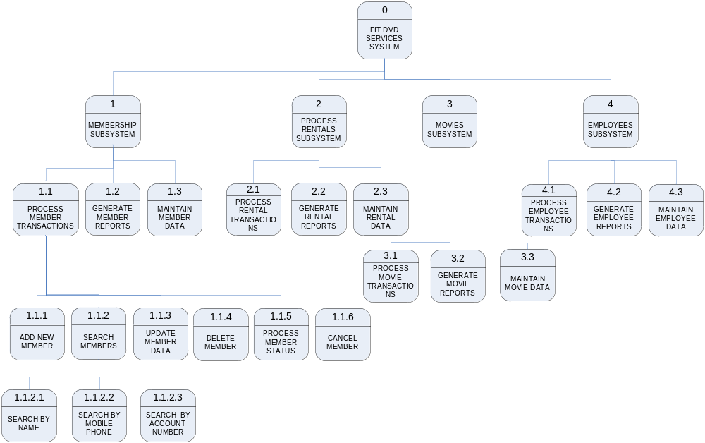

Figure 4: Part of the Decomposition diagram of FIT DVD club.

Data Flow Diagram (DFD) show how data flows around an information system.
They are a simple and powerful graphic technique which is both easily updated and easily understood by users. This is basically one of the main diagrammatic techniques of SSADM (Structured System Analysis and Design Methodology). SSADM is explained in Appendix A.

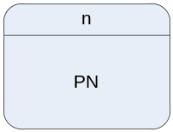

Process: Shows a transformation of data and is also referred to as a function.
n is the number of the process, this number also indicates the level of the process.
PN is the process name.


DFName
Data Flow / Physical Flow of data
DFName: Data Flow Name

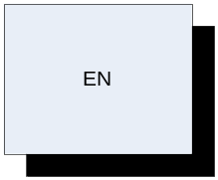
EN: Is the external entity name
External entity (source and/or sink of information) – destination. This can be a person, oranizational unit, system or another orgnization interacting with the system. Also, called external agent.

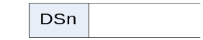
DSName
Data Store: Storage of Data
DSn - Data Store n (number)
DSName - Data Store name

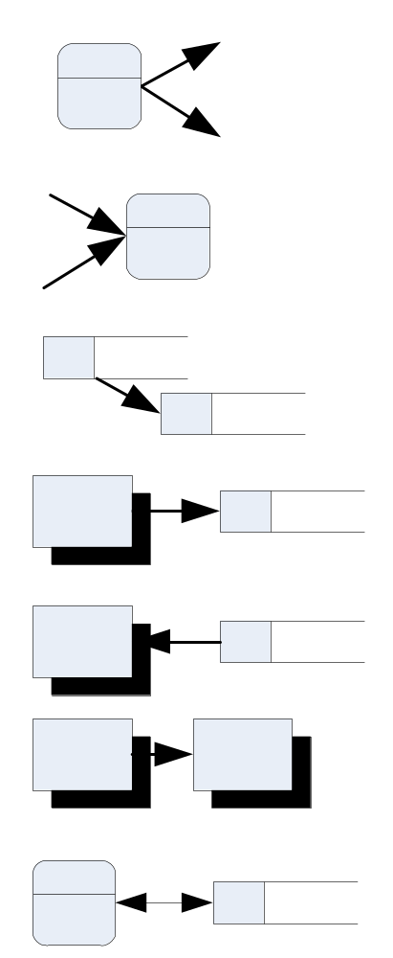Rules (all of the following are not permitted)

Miracle

Black Hole

` | P | D. S. | E.E
P | √ | √ | √
D. S. | √ | × | ×
E.E | √ | × | ×

Plus, additionally,

Each data store must have at least one input flow and one output flow (read & write).

Gray Hole: Insufficient input

What is a DFD?

A hierarchical set of diagrams which is used to define:

- the boundary of the system to be developed
- the information flow to and from the system
- data flows within the system
- the functions used by the system.

(used to define the project scope and to provide measures of performance - for use in estimating and planning).

How is it developed?
- Identify inputs & outputs.
- Label all data flows.
- Label all processes.
- Identify data stores.
- Label all External Entities.
- Start again.

Data Flows between
External entity and Process
Data Store and Process,
Process and Process

Note: Information (Data) held for any amount of time between processes is called a DataStore.

Example: (of a Level 0 D.F.D – also called the Context Diagram)

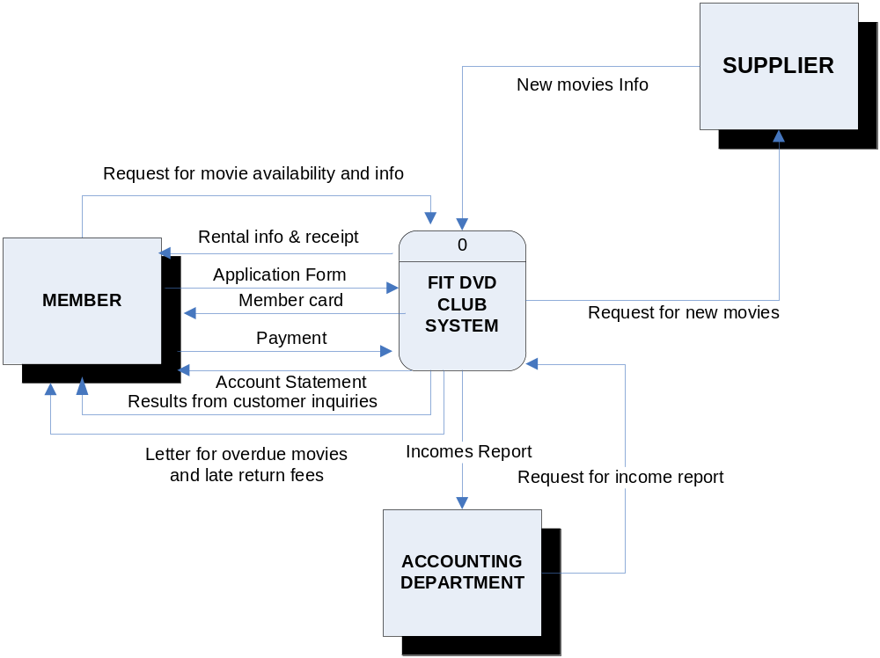

Object modelling
Is a technique which identifies objects and their relationships within a the system.

Unified Modeling Language (UML)294
An approach that utilizes object modelling languages.
5. Systems Design
The evaluation of alternative solutions and the specification of a detailed computer based solution. Also called physical design. Driven by system designers and/or system analysts.

Design System analysis (requirements)
System design deals with the physical or implementation dependent aspects of a system (the system’s technical specifications) HOW TO.

Systems design builds on the knowledge derived from systems planning and systems analysis.

Purchase software Vs Develop software (why reinvent the wheel).
Buy software packages – to fulfil end user requirements.

System Analyst
Primarily focused on the logical, implementation
independent aspects of the system (requirements).

System design
Deals with the physical or implementation
dependent aspects of a system (system’s technical specifications).

- Design process
3 phases of System Design
- Selection Phase - Evaluation and selection of alternative solutions
- Acquisition Phase - Acquisition or purchase of computer software and hardware
- Design & Integration Phase - Traditional physical design and integration of computer-based components

A. Selection Phase
Activities or Steps

- Specify alternative solutions
  - Ideas and opinions from system owner and users also system analysts and system designers
  - Technical consultants and other IS professionals

Some technical choices may be limited by a predefined approved technology architecture provided by system managers.

Candidate solutions
Candidate matrices (Page 478)

- Analyse feasibility of alternative solutions

2.1 Technical feasibility (technically practical, staff, expertise)
2.2 Operational feasibility
- Fulfil user requirements?
- What degree?
- Work environment change?
- How does users feel about such a solution

2.3 Economic feasibility
- Cost effective?

2.4 Schedule feasibility
- Design and implementation in acceptable period of time?

  - Recommend a solution

    - Infeasible candidate eliminated
    - Candidate that offers the best overall combination

      - System Proposal (for system owner for final decision)

Project plans
Size estimates
Candidate solutions
Feasibility analysis

B. Acquisition phase and system design
Step or Activity

1. Research Technical criteria and options
Research technical alternatives hardware and/or software requirements
Product and random facts from various sources
- Internal standards may exist for hardware and software selection.
- Information services (survey the marketplace for new products).
- Trade newspapers and periodicals.

  - Solicit Proposals (or Quotes) from Vendors

Baying from a single source Vs use the competitive marketplace

Request for quotation (RFO)
Request for Proposal (RFP)

- Validate Vendor claims and performance

- Evaluate and Rank Vendor
Cost benefit analysis

- Award (or Let) Contract and Debrief Losing Vendors

Winning Vendor Losing Vendors
contract
agreement

- Establish Integration Requirements
Integrate or interface the new system to the existing systems
Problems: different technology
techniques
structures

C. Establish Integration Requirements

  - Developing technical design specifications

    - Design and Integration Phase

General Design Detailed Design
Outline of the overall Developing the detail design
Design specifications for
components in the outline.

- Analyse and Distribute data

Data model exist development of ideal file and database solutions

Data analysis: A procedure that prepares a data model for implementation as a no redundant flexible, and adaptable file/database.

Normalization: The procedure that is used to simplify entities, eliminate redundancy and build flexibility and adaptability into a data model. Data attributes are grouped together – stable, flexible

Event analysis: A technique that studies the entities of a fully normalized data model to identify business events and conditions that cause data to be created, deleted or modified.

DFD’s may need to be revised.

- Analyse and Distribute process

- Factor into design units
Smaller pieces – design units

- Design computer files and/or Database
Not just layout of records
Future programs may use files and databases in way not original envisioned

- Design Computer Outputs and Inputs
Input and Output design requirements
End-users -ideas, suggestions, especially regarding format.

- Design On-line user interface
Dialogue between the end-user and computer easy to learn and easy to use dialogue.

- Present and Review Design
Computer program specifications that will guide the computer programmer’s activities during the construction phase of the SDLC.

    - Implementation plan
    - A final cost benefit analysis

Review the system with
      - System users
      - System owners
      - Technical support staff
      - Audit staff

Installation of the system: Phase, Direct, Pilot, Parallel

6. Input/Output Design and user interfaces

Data Entry Methods and Devices

Keyboard. Most keyboards contain the letters of the alphabet, but not all do, for instance most calculator keyboards are very different, as are the keyboards for use at ATM machines. The characters needed for specialist use machines are determined by the use to which the machine is to be put. Keyboards are the most common form of input device to a system because they are universally available and understood.
The common keyboard is known as the QWERTY keyboard because those are the first six characters on the top line.
Ergonomic keyboards.
Touch-sensitive keyboards, or concept keyboards, they are ideal for use outside because rain will not damage them like a normal keyboard.
Musical keyboard. Normally arranged like a piano keyboard these need a special piece of hardware to allow them to work properly, known as a MIDI (musical instrument digital interface)

Mouse. It is particularly useful because it mimics the natural human reaction of being able to point at something.
Tracker ball used in many laptop computers.
Touch Pad

Keyless Data Entry
Keying errors have always been a major source of errors in computer inputs (and inquiries). Any technology that reduces or eliminates the possibility of keying errors should be considered for system design.

OCR (optical character reader). This is a device that reads characters and can distinguish between the different characters in a given character set. It works by comparing the shape of a scanned character with a library of shapes that it is intended that it should recognise. OCR tends to be an unreliable form of input and works more effectively when it is restricted to having to recognise a standard character set produced by printing rather than by using hand writing. OCR is used for reading post codes on printed documents and also for reading documents for blind people, the contents of which can be output using a voice synthesizer.

OMR (optical mark reader). This device can recognise the presence of a mark on a sheet of paper. The position of the mark conveys information to the machine. For example a school register may consist of a list of names of pupils in a class together with two columns of small rectangles, one for present and one for absent. The same action (shading in a rectangle) stands for both being present and being absent. The difference is the position that the mark occupies on the paper. Printing in the sensitive areas of the sheet is done using a special type of ink which the optical scanner does not see, that is why OMR documents tend to be printed in a light blue or pink colour. The other standard use for OMR documents is as multi choice examination answer sheets.

MICR (magnetic ink character reader). This is a device that reads characters that are printed on an original document at the time of it being created. The characters are printed using magnetic ink. The value is that the characters are readable by humans and by machines. The only common use for such characters is the data printed on the bottom of cheques containing account identification.

The big advantage of both OCR and OMR is that data can be input to a computer system without having to be transcribed first, thereby cutting down the number of errors on data input.

The real advances in keyless data entry are coming for on-line systems. Bar coding systems (similar to universal product code systems that are commonplace in the grocery and retail industries) are widely available for many modern applications. For example, Federal Express creates a bar code-based label for all packages when you take the package to a centre for delivery. The bar codes can be read and traced as the package moves across the country to its final destination.

Barcode readers. A barcode reader is a laser scanner that reads the reflected laser light from a series of dark and light coloured lines of varying thickness. The different widths of pairs of lines make up a code that can be converted into a number. This number can then be used as the keyfield relating to a file of items that have been barcoded. The details of the contents of the barcodes are not of importance to us in this section, except to say that barcodes can easily be misread by the system, so one of the digits in the number is used to check that the rest of the code has been read properly. This digit is called the check digit, and will be discussed in more detail later in the course. Barcodes are particularly useful because they do not rely on human beings to input the data, although, if the barcode is damaged so that the laser scanner cannot read it properly, the digits represented by the code are printed underneath so that they can be input by a user at a keyboard. Barcodes are used where the data does not change, and so can be printed on original packaging.

Keyless data entry should be considered for appropriate high-volume transaction-based systems as they become candidates for redesign.

Pen Input
Pen-based computing is starting to evolve. As pen-based operating systems (e.g., Microsoft's Pen Windows) become more widely used and tools for building pen-based applications become available, we expect to see more system designs that exploit this technology. Some businesses already use this technology for remote data collection. For example, UPS uses pen-based notebook systems to communicate deliveries to drivers and to collect delivery confirmation signatures and data from customers and drivers. When a driver returns to their distribution centre, the data is transmitted from the pen-based notebook computer to host computers.

Scanners. A scanner is a device that converts a document into a series of pixels (picture elements – these are small squares that, when put together, form a picture). The larger the number of pixels, or conversely the smaller each individual pixel, the better the definition of the final picture. There are different types of scanner, but all use the same principle to create the image. A typical use for a scanner would be to input a picture of a house so that it could be included with the details of a house that is for sale in an estate agent’s publication.

Graphics Tablet. A graphics tablet is a flat surface on which a piece of paper is placed. The user can then draw on the paper and the tablet will sense where the pencil is pointing and transfer the line to the screen.

Microphones. Used to input sound to a computer system.

Output Methods and Devices
There are too many output devices to be able to write notes on all of them. Again, the same thing is true about output as is true about input, that it is important to know about those devices stated in the syllabus and also a range of devices that will allow for sensible decisions about peripheral devices to be made for a given scenario in a question.

Screens. Monitor screens are categorised according to the obvious colour/monochrome, also according to the number of pixels that there are on the screen. The more pixels there are, the better the picture will be, known as the screen resolution. This is being typed using a very low resolution, monochrome screen. If you consider the contents, there is no reason for any further sophistication to be necessary. However, a computer system running a game program will need colour and many more pixels in order to produce a satisfactory picture. The more pixels that there are on the screen, the higher the resolution is said to be.
A particular type of screen, called a touchscreen, acts as both an input device and an output device. Information is output by the system onto the screen and the user is invited to answer questions or make choices by pointing at a particular area of the screen. The device can sense where the user is pointing and can report the position to the processor. The processor can then deduce what the user’s reply was according to the position that was pointed to. Touchscreens are particularly useful in areas where keyboards are not appropriate, e.g. where the device may suffer from vandalism. They are also useful for users who would find difficulty using other input devices, e.g. very young children who want to be able to draw on a screen.

Printers. A printer is a device which provides the user with an output from the system which is permanent. This output is known as hard copy, so a printer is a device which produces hard copy. There are many different types of printer and the student should be aware of a number of them, their uses, advantages and disadvantages. However, there is no need to understand how they work.
The first type is a dot matrix printer. These tend to be slow, and the output is particularly poor quality. The big advantage is that the output is produced by using pins to strike at the surface of the paper. Because of the physical nature of the way that the printout is produced, it is possible to obtain multiple copies by using carbon paper or self carbonating paper. A good example of this is the receipt that a shopper is presented with if buying something using a credit card, there are two copies produced, back to back, one for the shop to keep and one for the buyer to take away with them.
Ink jet printers, which produce output by spraying ink on to the paper could not produce the two copies that the dot matrix can, but it can produce much better quality and in colour, at low cost. This makes ink jet printers ideal for home use.
Laser printers can produce very high quality work at high speed. The cost is more than with the other types but used where it is necessary to give a good impression, for instance sending letters from a solicitor’s office to clients.
Plotters are a type of printer designed for drawing lines and geometric designs rather than for producing characters. The image is created by pens being moved across a piece of paper, under the command of the processor. Plotters tend to be used for drawing blueprints, perhaps in an architect’s office to produce detailed drawings of buildings for builders to follow.

Speakers. Used to output sound from a computer system.

There are many other peripheral devices and, as has been mentioned, knowledge of some others will not come amiss, however that is enough to be able to answer questions in the exam. The questions will normally take the form of presenting a scenario and then asking for a description of the hardware required. The important thing to remember is how the marks will be awarded. There will not be a mark for every device mentioned, but the candidate will be expected to give sensible suggestions for each of the four areas of peripherals mentioned at the start of this section. In other words the mark will not be for a keyboard or a mouse, but for suggesting sensible methods of input to the system.

Graphical user interfaces

Graphical user interfaces are a method of user communication with an operating system. Through the interface, the user gives the operating system commands. With a graphical user interface, rather than typing commands, the user will select icons, buttons, bars or boxes to perform a task. Usually a mouse is used to make the selection. Many people believe that graphical user interfaces are quick and easy to learn, promote standardization of application program interfaces and reduce errors.

Graphical user interfaces (GUIs) were popularized by the success of Apple's Macintosh and Microsoft's Windows. While the commercial success has been driven by applications such as word processing and spreadsheets, the popularity of the interface is driving all applications to the interface.

Technology exists to create GUI-like applications for dumb terminals. Technology also exists to create true PC-based GUIs that work with host applications via cooperative processing. And most importantly, GUI technology has become the user interface of choice for client/server applications.

GUIs do not automatically make an application better. Poorly designed GUIs can negate the alleged advantages of consistent user interfaces. Fortunately, GUI standards are evolving to guide system designers to create consistent interfaces. For example, DOS/Windows and OS/2 Presentation Manager are based on a standard called Common User Access (CUA). Properly designed GUIs simplify input, reduce keystrokes required, and provide interesting and useful formatting options for outputs. Many businesses are mandating their use for all new systems.

System User Issues for Input and Output Design

Because inputs originate with system users and outputs are used by system users, human factors play a significant role in both input and output design. inputs should be as simple as possible and designed to reduce the possibility of incorrect data being entered. System users must find computer outputs easy to use and helpful to their jobs. Furthermore, if batch input methods are used, the needs of data entry clerks must also be considered. With this in mind, several human factors should be evaluated.

First, the volume of data to be input should be minimized. The more data that is input, the greater the potential number of input errors and the longer it takes to input that data. These general principles should be followed for input design:

• Enter only variable data. Do not enter constant data. For instance, when deciding what elements to include in a SALES ORDER input, we need PART NUMBERs for all parts ordered. However, do we need to input PART DESCRIPTIONs for those parts? PART DESCRIPTION is probably stored in a computer file. if we input PART NUMBER, we can look up PART DESCRIPTION. Permanent (or semi-permanent) data should be stored in files. Of course, inputs must be designed for maintaining those files.

• Do not input data that can be calculated or stored in computer programs. For example, if you input QUANTITY ORDERED and PRICE, you don't need to input EXTENDED PRICE, which is equal to QUANTITY ORDERED X PRICE. Another example is incorporating FEDERAL TAX WITHHOLDING data in tables (arrays) instead of keying in that data every time.

- Use codes for appropriate attributes. Codes were introduced earlier. Codes can be translated in computer programs by using tables.

Second, source documents should be easy for system users to complete. The following suggestions may help:

- Include instructions for completing the form. Also, remember that people don't like to have to read instructions printed on the back side of a form.

- Minimize the amount of handwriting. Many people suffer from poor penmanship. The data entry clerk or CRT operator may misread the data and input incorrect data. Use check boxes wherever possible so the system user only needs to check the appropriate values.

Third, design documents so that they can be easily and quickly entered into the system. We suggest the following:

- Data to be entered (keyed) should be sequenced so it can be read like this book, top to bottom and left to right (see Figure 16A). The data entry clerk should not have to move from right to left on a line or jump around on the form (see Figure 16AB) to find data items to be entered.

- Ideally, portions of the form that are not to be input are placed in or about the lower right portion of the source document (the last portion encountered when reading top to bottom and left to right). Alternatively, this information can be placed on the back of the form.

These are only guidelines. System users should have the final say on source document design! Many of these same system user issues also apply to output design. The following general principles are important for output design:

- Computer outputs should be simple to read and interpret. These guidelines may enhance readability:

- Every report or output screen should have a title.
- Reports and screens should include section headings to segment large amounts of information.
- Information in columns should have column headings.
- Because section headings and column headings are frequently abbreviated to conserve space, reports should include legends to interpret those headings.
- Legends should also be used to formally define all fields on a report. You never know whose hands a report might end up in! (Note: Legends can be built into on-line outputs using function keys to temporarily interrupt the output to display legends and help.)
- Computer jargon and error messages should be omitted from all outputs.

On many computer outputs, these guidelines are ignored or overlooked; consequently, the outputs appear cluttered and disorganized.

- The timing of computer outputs is important. Outputs must be received by their recipients while the information is pertinent to transactions or decisions. This can affect how the output is designed and implemented.

- The distribution of computer outputs must be sufficient to assist all relevant system users.

- The computer outputs must be acceptable to the system users who will receive them. An output design may contain the required information and still not be acceptable to the system user. To avoid this problem, the systems analyst must understand how the recipient plans to use the output.

Internal Controls for Inputs and Outputs

Internal controls, a continuing theme throughout the design chapters of this book, are a requirement in all computer-based systems. Input controls ensure that the data input to the computer is accurate and that the system is protected against accidental and intentional errors and abuse, including fraud. Output controls ensure the reliability and distribution of the outputs generated by the computer. The following internal control guidelines are offered for inputs:

- The number of inputs should be monitored. This is especially true with the batch method, because source documents may be misplaced, lost, or skipped.
- In batch systems, data about each batch should be recorded on a batch control slip. Data includes BATCH NUMBER, NUMBER OF DOCUMENTS, and CONTROL TOTALS (e.g., total number of line items on the documents). These totals can be compared with the output totals on a report after processing has been completed. if the totals are not equal, the cause of the discrepancy must be determined.
- In batch systems, an alternative control would be one-for-one checks. Each source document would be matched against the corresponding historical report detail line that confirms that the document has been processed. This control check may only be necessary when the batch control totals don't match.
- In on-line systems, each input transaction should be logged to a separate audit file so it can be recovered and reprocessed in the event of a processing error or if data is lost.

- Care must also be taken to ensure that the data is valid. Two types of errors can infiltrate the data: data entry errors and invalid data recorded by system users. Data entry errors include copying errors, transpositions (typing 132 as 123), and slides (keying 345.36as 3453.6). The following techniques are widely used to validate data:
- Completeness checks determine whether all required fields on the input have actually been entered.
- Limit and range cheeks determine whether the input data for each field falls within the legitimate set or range of values defined for that field. For instance, an upper-limit range may be put on PAY RATE to ensure that no employee is paid at a higher rate.
- Combination checks determine whether a known relationship between two fields is valid. For instance, if the VEHICLE MAKE is Pontiac, then the VEHICLE MODEL must be one of a limited set of values that comprises cars manufactured by Pontiac (Firebird, Grand Prix, and Bonneville to name a few).
- Self-checking digits determine data entry errors on primary keys. A cbeck digit is a number or character that is appended to a primary key field. The check digit is calculated by applying a formula, such as Modulus 11, to the actual key (see Figure 16.5). The check digit verifies correct data entry in one of two ways. Some data entry devices can automatically validate data by applying the same formula to the data as it is entered by the data entry clerk. if the cheek digit entered doesn't match the check digit calculated, an error is displayed. Alternatively, computer programs can also validate check digits by using readily available subroutines.
- Picture checks compare data entered against the known COBOL picture or other language format defined for that data. For instance, the input field may have a picture clause XX999AA (where X can be a letter or number, 9 must be a number, and A must be a letter). The field "A4898DH" would pass the picture check, but the field "A4891DW' would not.

Data validation requires that special edit programs be written to perform checks. However, the input validation requirements should be designed when the inputs themselves are designed.

Internal controls must also be specified for outputs. The following guide lines are important output control issues:

1. The timing and volume of each output must be precisely specified. You cannot simply state that a report is needed daily. When daily? 8:00 AM? 10:30 AM2 2:00 P.m.? Computer facilities have limited resources, and the systems analyst must frequently negotiate an appropriate schedule with the computer operations staff.

2. The distribution of all outputs must be specified. For each output, the recipients of all copies must be determined. A distribution log, which provides an audit trail for the outputs, is frequently required.

3. Access controls are used to control accessibility of video (on-line) outputs. For example, a password may be required to display a certain output on a CRT terminal.

- Control totals should be incorporated into all reports. These controls can be compared with the input controls that will be discussed later in the chapter. The number of records input should equal the number of records output. These control totals are compared before the outputs are distributed. If a discrepancy is found, the outputs are retained until the cause has been determined and corrected.

Indexed sequential access method and the direct file access method.

The indexed sequential access method (ISAM) is a way of storing data records on a physical storage device in sequential order for sequential processing (such as in payroll applications). However, ISAM also allows any specific record to be directly accessed without searching through the file sequentially by using the record's key field to find its storage address in an index.

The difference between batch and on-line processing

Batch processing involves “batching” transactions together and then applying these accumulated transactions as a group or “batch” at some later point to update a computer system master file. On-line processing involves entering a transaction directly into the computer and processing it immediately. With on-line processing, information in the system is always up-to-date and current.
Real - Time

Methods of interacting with a system.

- command language: A human computer interaction method where users entered explicit statements into a system to invoke operations.
- Menu: A human computer interaction method where a list of system options is provided and a specific command is invoked by user selection of a menu option
- Form: A highly intuitive human-computer interaction method whereby data fields are formatted in a manner similar to paper based forms.
- Object: A human computer interaction method where symbols are used to represent command or functions.
- natural language: A human-computer interaction method whereby inputs to and outputs from a computer base application are in conventional speaking language such as English.

Fourth-generation languages

"Fourth-generation" languages are extremely sophisticated languages which enable end-users to perform programming tasks with little or no professional programmer assistance or that enhance the productivity of professional programmers. For example, very high-level programming languages, query languages, or application generators have features that can be employed by end-users or less skilled programmers and can dramatically increase application development productivity.

Categories of fourth-generation tools.

The seven categories of fourth-generation tools are:

• Query languages: high-level languages for retrieving data from databases and files which can support requests for information that are not predefined. Tend to be on-line and interactive.
• Report generators: facilities for extracting data from files or databases to create reports in many formats.
• Graphics languages: facilities for displaying data from files or databases in graphic format.
• Application generators: preprogrammed modules that can generate code for input, validation, processing, update, and reporting when users provide specifications for an application.
• Very high level programming languages: perform coding with far fewer instructions than conventional languages.
• Application software packages: pre-written application software that is marketed commercially.
• Microcomputer tools: general-purpose application packages developed for microcomputers, especially word processing, data management, graphics, desktop publishing and spreadsheet software.

7. TESTING and DEBUGGING

7.1 TESTING

When a system is designed it is important that some consideration is given to making sure that no mistakes have been made. A schedule should be drawn up which contains a test for every type of input that could be made and methods of testing that the program actually does what it was meant to do. This schedule is known as the test plan. Note that it is produced before the system is produced.
There are a number of ways of testing a program.

1. Black box testing
Different values can be input for variables to determine whether the program can cope with them. These values should include typical values, borderline values and values which are not acceptable. For example, if a program is written which uses marks out of 100 from a maths examination as input, the test data would include typical data like 27, 73.., borderline data which would be 0 and 100, and unacceptable data like –34, 123, 16.345 This type of testing is called black box testing.

2. White box testing is testing the program to determine whether all the possible paths through the program produce the desired results. As a large program can have a very large number of routes, when you take into account the different condition statements and loops, white box testing is rarely carried out exhaustively.
Think of black box as a test where you cannot see into the box (program) all you see is what comes out at the end. White box testing means that you are able to see what is happening as the data goes through the box because it is transparent.

Alpha and Beta testing. When you have written a program and you sit down to test it, you have a certain advantage because you know what to expect. After all, you wrote the program. This can be extended to the whole software company, as the employees are all computer-minded people. Testing carried out by people like this is known as alpha testing. Eventually, the company will want ordinary users to test the program because they are likely to find errors that the software specialists did not find. Testing carried out by the users of the program is called beta testing.

Selection of test data
If a solution is to be tested, someone has to choose what data is going to be used to do the testing. The test data is usually chosen by the programmer because they know what they want to test. It is important to test as many different things as possible, the important word there being ‘different’. The problem for the programmer is that they know what inputs were expected so they find it very difficult to think of the sort of inputs that the user of the program might try to put in.

When you are asked to think up different inputs to test a program, it must be different types of input, not just changing numbers. Imagine a question that states that a program has been written that will work out the mean of three numbers. You have to come up with different test data and the reasons for doing those tests. That last bit is in bold because that is what you get the marks for and the reasons for the tests are the things that have to be different. In this example you would may thinking of

1, 2, 3 to test whether integers will give an integer answer
1, 2, 4 to test whether the software can cope with a recurring decimal answer
(Note that “1, 2, 4 to test a different set of integers” would not get a mark because the reason for the test is not different)
1, 2.5, 3 to test whether the program can use decimal inputs
1, 2½, 3 to test whether fractions are allowed
-1, -2, -3 to test whether negative numbers can be handled
1, 2 to test what happens when only two values are input

There are many more that would be acceptable. The important thing to notice is that the numbers themselves are almost identical but that the reasons for choosing them are very different.

7.2 Debugging
Errors in computer solutions are called bugs. They create two problems. One is that the error needs to be corrected, this is normally fairly straightforward because most errors are caused by silly mistakes. The second problem, however, is much more complicated, the errors have to be found before they can be corrected. Finding where the error is and identifying it, can be very difficult and there are a number of techniques available for solving such problems.
- Translator diagnostics. Each of the commands that are in the original program is looked at separately by the translator. Each command will have a special word which says what sort of command it is. The translator looks at the special word in the command and then goes to its dictionary to look it up. The dictionary tells the translator program what the rules are for that particular special word. If the word has been typed in wrongly, the translator will not be able to find it in the dictionary and will know that something is wrong. If the word is there, but the rules governing how it should be used have not been followed properly, the translator will know that there is something wrong. Either way, the translator program knows that a mistake has been made, it knows where the mistake is and, often, it also knows what mistake has been made. A message detailing all this can be sent to the programmer to give hints as to what to do. These messages are called translator diagnostics.
- Sometimes the program looks alright to the translator, but it still doesn’t work properly. Debugging tools are part of the software which help the user to identify where the errors are. The techniques available include:
  - Cross-referencing. This software checks the program that has been written and finds places where particular variables have been used. This lets the programmer check to make sure that the same variable has not been used twice for different things.
  - Traces. A trace is where the program is run and the values of all the relevant variables are printed out, as are the individual instructions, as each instruction is executed. In this way, the values can be checked to see where they suddenly change or take on an unexpected value.
  - Variable dumps. At specified parts of the program, the values of all the variables are displayed to enable the user to compare them with the expected results.
- Desk checking is sometimes known as a dry run. The user works through the program instructions manually, keeping track of the values of the variables. Most computer programs require a very large number of instructions to be carried out, so it is usual to only dry run small segments of code that the programmer suspects of harbouring an error.
- The splitting up of a problem into smaller and smaller parts, until each part was a manageable size as we all know is very important. When the parts were combined they would produce a solution to the original problem. Because we are starting with a big problem and splitting it into smaller problems, this was called top-down design. When the program is written, each small program is written separately, allowing the small programs to be tested thoroughly before being combined. This is called bottom-up programming. The technique is particularly useful for testing the finished program because it is far easier to test a lot of small programs than it is to test one large one. One problem can arise, because the small programs have to be joined together, these joints have to be tested too to make sure that no silly mistakes have been made like using the same variable name for two different things in two parts of the program (tested by cross referencing).
- Test strategies are important to establish before the start of testing to ensure that all the elements of a solution are tested, and that unnecessary duplication of tests is avoided.

7.3 Installation - Integration
Any system needs to be tested to ensure that it works. This seems to be a fairly obvious statement, but in reality such testing is impossible in all but the simplest of systems because it simply is not possible to test every conceivable input to, or logical construction in, the system. This difficulty means that testing that is to be done must be carefully planned and that it should relate directly to the criteria referred to earlier in this section.

When the system has been completed it has to be implemented so that it is performing the tasks for which it was designed. Initially, this involves
- ensuring that the correct hardware is available
- arranging for staff to be trained in the use of the new system
- inputting the data to the data files, either manually or by downloading them from the original system.
The system handover, itself can be done in a number of ways:
- Parallel running. Until the system can be considered fault free, the old and new systems are run side by side, both doing the same processing. This allows results to be compared to ensure that there is no problem with the new system. Such a system is ‘safe’ and also allows staff training to be carried out, but it is obviously very expensive because of the need to do everything twice. Parallel running is used in situations where the data is so valuable that there must be no possibility of failure.
- Pilot running. Key parts of the new system are run alongside the old system until it is considered that they have been fully tested. This is a compromise with the idea of parallel running, but it does not give a clear idea of the effects on the system of the large amounts of data that are going to be encountered in the full application.
- Big bang, or direct change. The old system is removed and the new system replaces it completely and immediately.
- Phasing. Parts of a system are replaced while the remaining parts are covered by the old system. This allows for some testing of the new system to be done, and for staff training to take place, but also allows for a back-up position if the new version does not work as anticipated.

APPENDIX A

SSADM – Structured System Analysis and Design Methodology

Principles of SSADM
  - Data Driven
  - Logical and Physical Concepts are separated
  - Iterative Development
  - Logical to Physical Conversion in Prescriptive
  - Performance Estimation and Optimisation before Implementation
  - Active User Involvement
  - Top-down Approach
  - Regular Reviews

SSADM Input – Statement of Requirements
SSADM Output – Program Specification
File/Data Base Specifications
User and Operations Specifications

3 Analysis Stages
3 Design Stages

Techniques used in Methodology
DFDs – Data Flow Diagram(s)
LDSs – Logical Data Structure
ELHs – Entity Life Histories
Process Outlines
TNF – Third Normal Form Data Analysis
1st Cut Design Rules
Plus, Quality Assurance Review and Formal Documentations

The aims of SSADM:
- Better project structure, leading to better planning
- More effective use of inexperienced staff
- Better control and monitoring of progress resulting from task breakdown
- Closer user invlovement
- Better communication with user through documentation
- Higher quality of analysis and design leading to potential lower costs
- Demonstrably provable systems design logic

Structural framework of SSADM
SSADM consists of three phases: feasibility, (optional)
analysis and
design
Each phase is divided into stages and
Each stage is divided into steps.
These in turn are divided into tasks.

SSADM Structure

Phase 1
Feasibility Study
Stage 01 – Problem definition
Stage 02 – Project identification

Phase 2
Systems Analysis
Stage 1 – Analysis of systems operations and current problems
Stage 2 – Specification of requirements
Stage 3 – Selection of technical options

Phase 3
System Design
Stage 4 – Data design
Stage 5 – Process design
Stage 6 – Physical design

